FANoFAN
E-Project
Design Guide
Supervisor: Miss Mahnoor
Group Member
Enrolment ID | Name
Student1691666 | Areeba Saleem
Student16885546 | Kanwal Khan
Student1691661 | Naveed
Student1691668 | Hussain
Student1692437 | Mudasir

Curriculum:7144
Batch Code:2507E8

Semester: 1st semester(ADSE)

Explore Premium Cooling with FANoFAN

“FANoFAN is an e-commerce and informational website designed to showcase a wide range of high-quality fans, including ceiling, wall, and pedestal models. The website provides clear product images, detailed specifications, pricing information, and easy navigation to help users quickly find the fan that suits their needs. It also includes features such as add-to-cart functionality, downloadable product details, and a responsive layout for smooth browsing on all devices. Overall, FANoFAN aims to deliver a simple, user-friendly, and reliable online experience for customers looking for cooling solution”

Objectives of the Website

- Provide detailed information about different types of fans.
- Offer an easy and smooth online shopping experience.
- Display clear product images, specifications, and prices.
- Enable users to add products to the cart and download product details.
.

Problem statement
FANoFAN Company is into manufacturing and selling on Fans. They manufacture fans
for various needs of customers. From Ceiling Fans to Table Fans to Exhaust Fans,
they are into all types of Fan Manufacturing.
They are looking to come up with their own website and display all the products
available with them. They want to provide a detailed information about all their
products.
Requirement Specification:
The Web site is to be created based on the following requirements.
1) The Home Page should be created making use of Sections with a suitable
logo, the header section can be added which will show images Fans.
2) The site must contain the links to navigate through any category for the
information.
3) Links of bottles can be categorized like (Ceiling Fans, Table Fans, Exhaust
etc.)
4) Specification and Pricing of Fans can be added along with the images.
5) Gallery section can be added for viewing different images.
6) Feedback must be allowed to enter by the viewer
7) Site map, Gallery, about us, Queries link, Contact us link must be added.
8) The complete description must be allowed to get download as pdf or doc file.
9) The advertise section with various facilities provided should be mentioned.

Hardware/ Software Requirements

- A minimum computer system that will help you access all the tools in the
courses is a Pentium 166 or better
- 64 Megabytes of RAM or better
Software [Either or Combination as per Course/Sem]
• Notepad/HTML editor/CoffeeCup
• Angular / Angular JS / React / BootStrap
• Dreamweaver / Figma
• MS IE / Chrome / FireFox / Netscape /MS Edge

1.Home

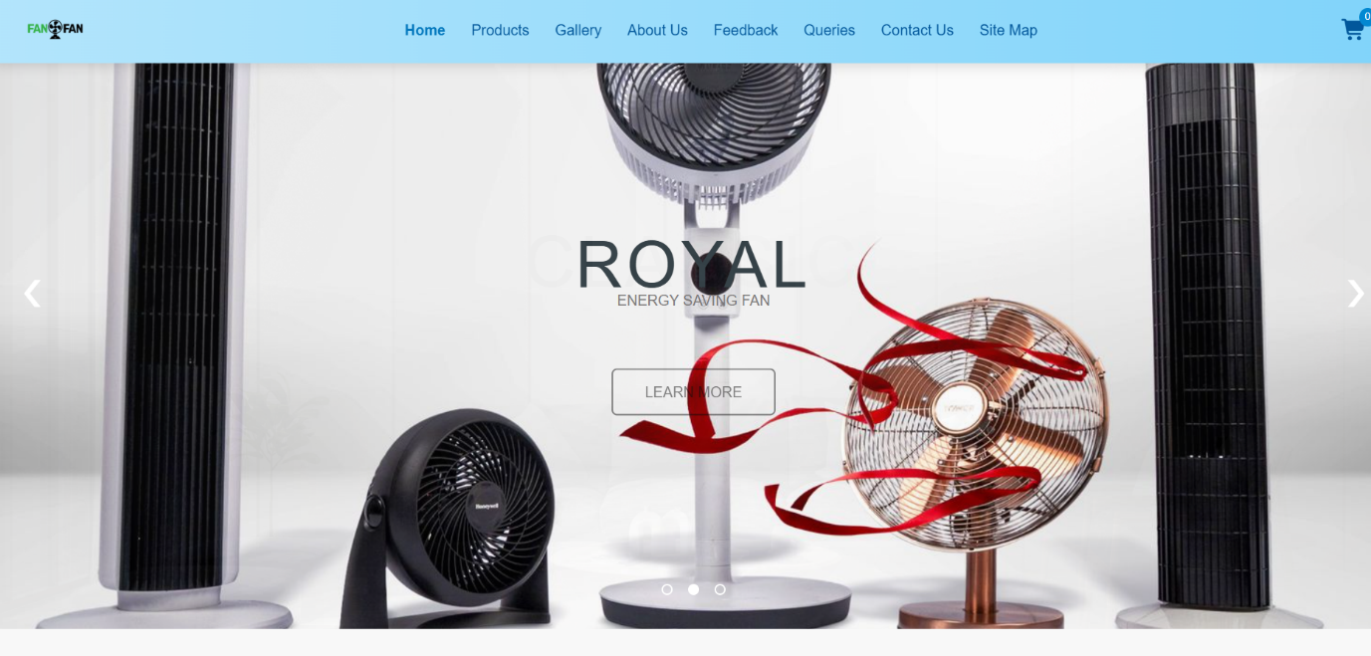

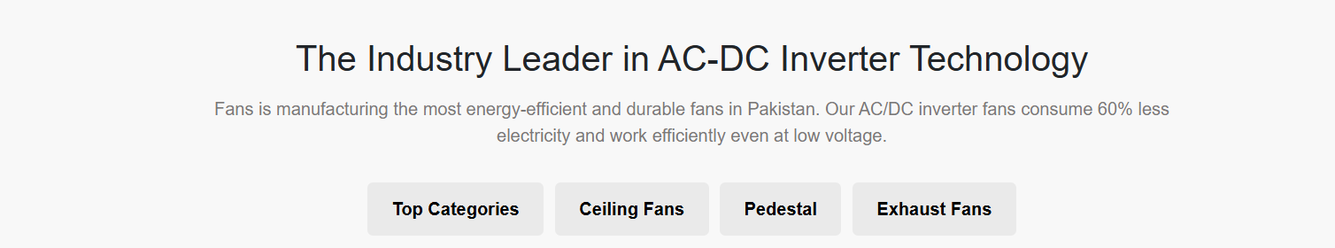

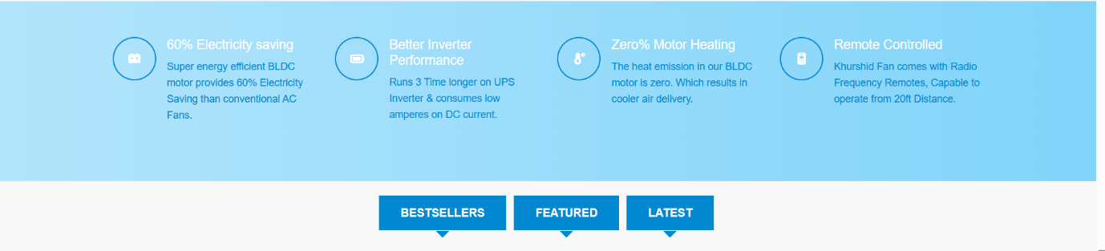

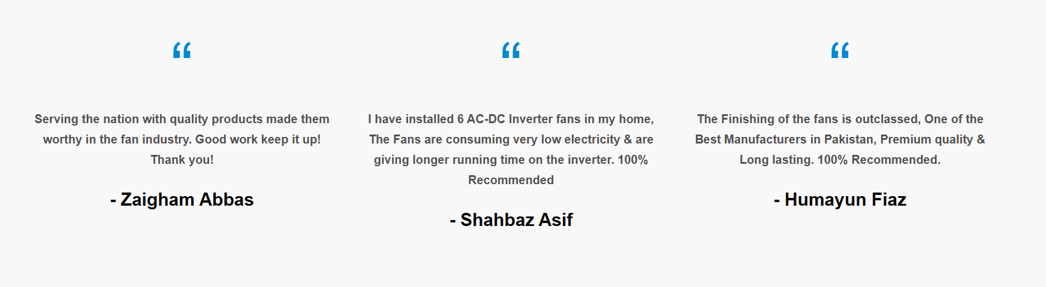

"FANoFAN is a premium online platform offering high-quality fans. Our website is designed to provide a seamless shopping experience, showcasing a wide range of fans to suit every need."

2. Product
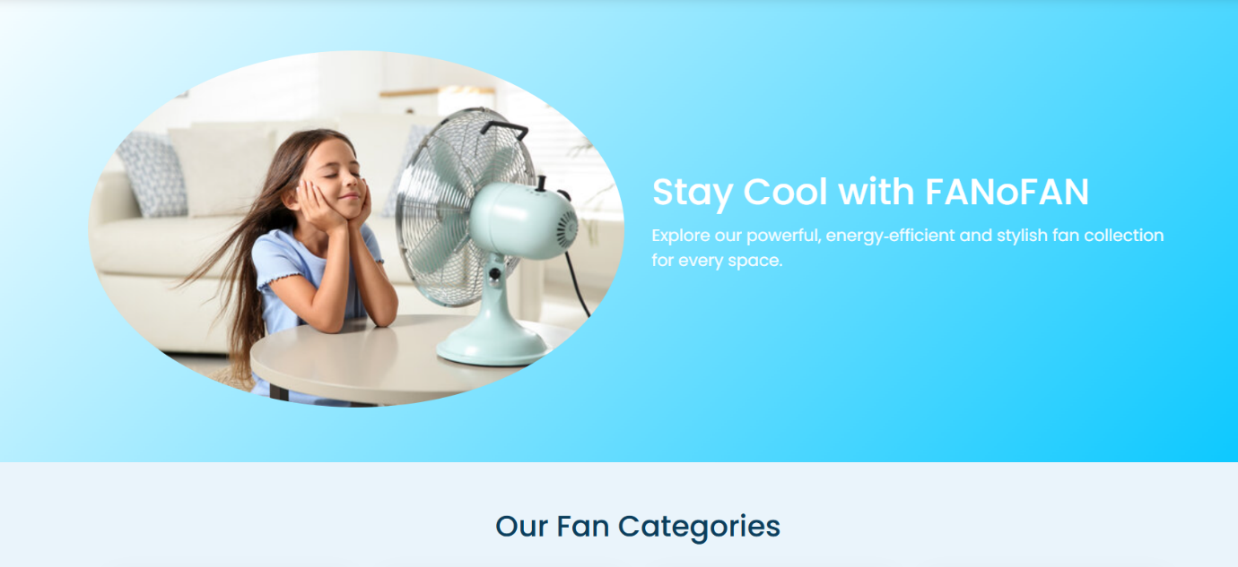
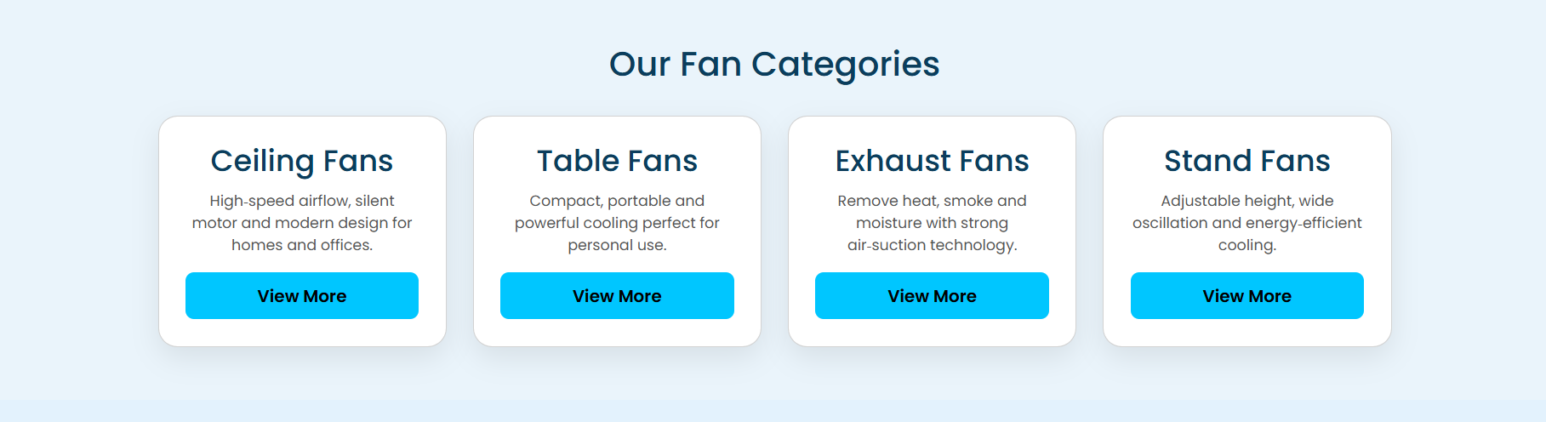
"Explore our comprehensive range of fans at FANoFAN. Our Ceiling Fans are designed to provide optimal airflow and elegance for any room. The Exhaust Fans ensure efficient ventilation, perfect for kitchens and bathrooms. Our Stand Fans offer flexible cooling for any space, while our Table Fans are perfect for personal use, delivering convenient and portable comfort."

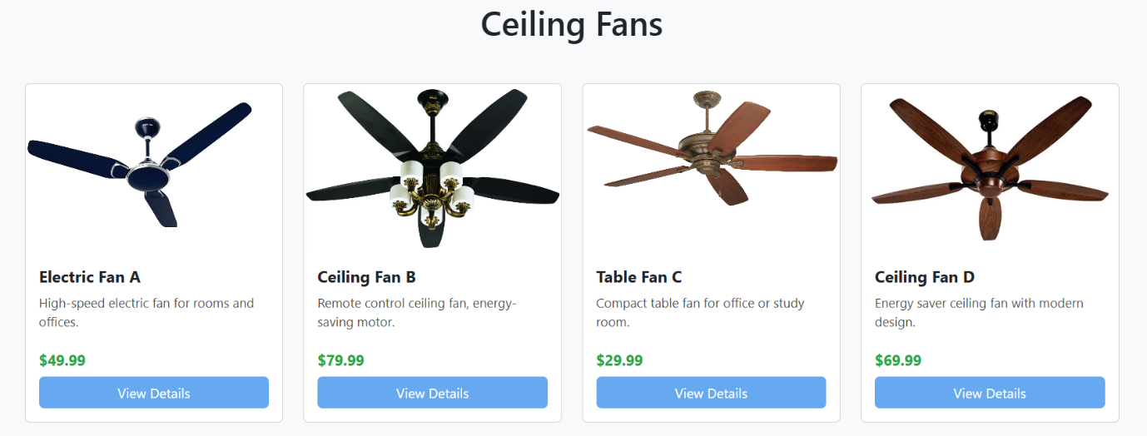

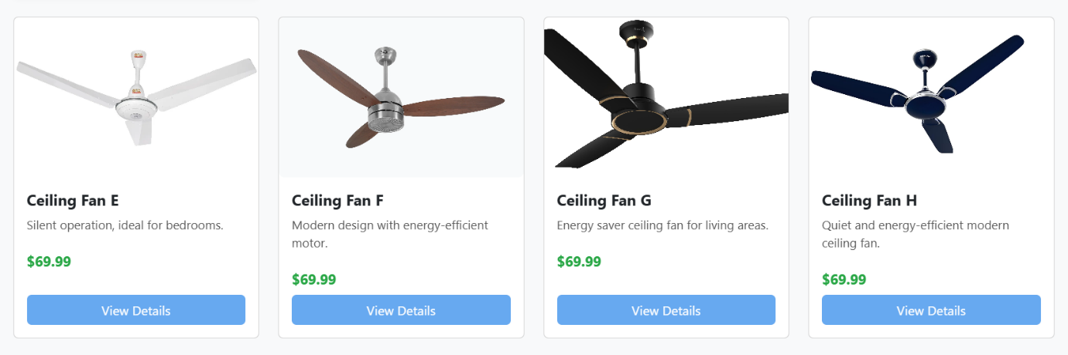

3.Gallery



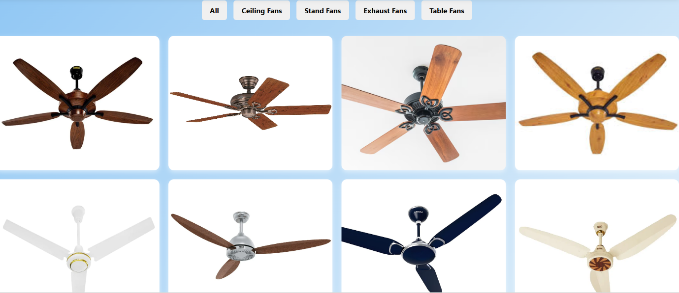

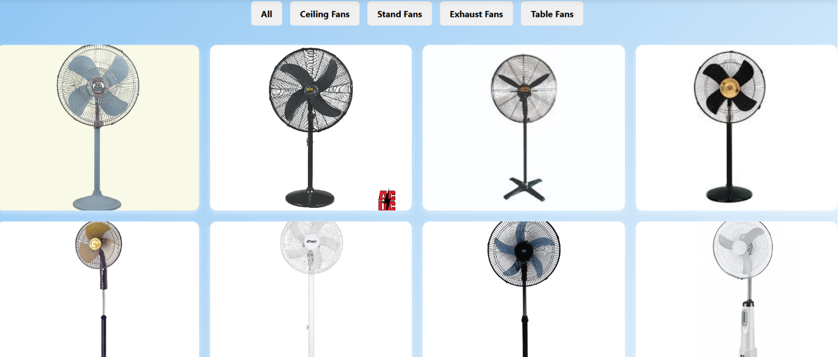

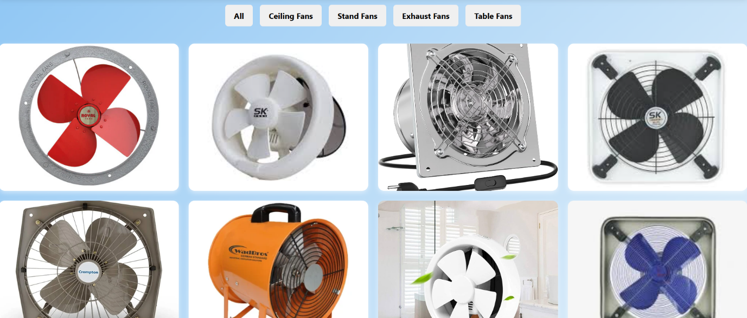

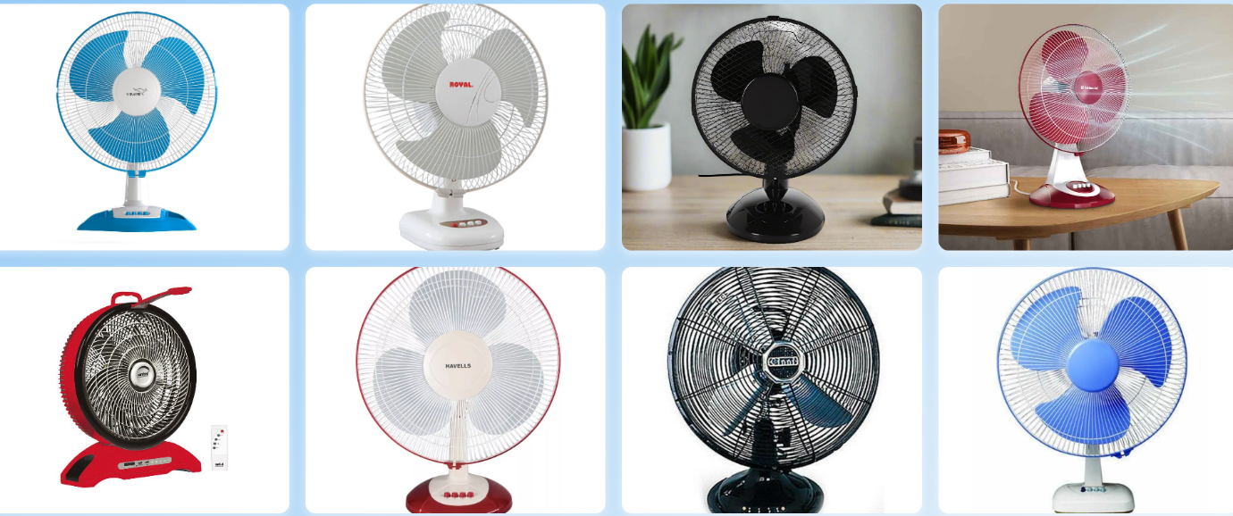
4.About
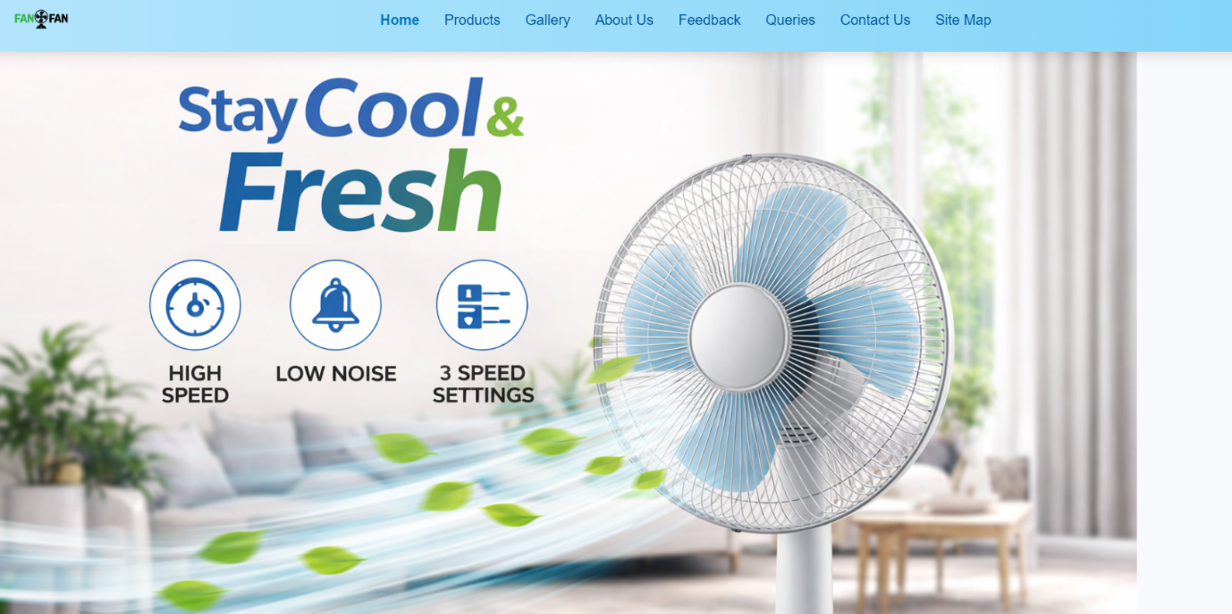

• Company Mission: Dedicated to providing high-quality fans that combine innovation and efficiency.
• Product Range: Offering a diverse selection of ceiling fans, exhaust fans, stand fans, and table fans to suit every need.
• Quality Craftsmanship: Committed to excellence in design and durability, ensuring long-lasting performance.
• Customer Focus: Prioritizing customer satisfaction with exceptional service and support.
• Innovative Technology: Integrating the latest advancements to enhance performance and energy efficiency.


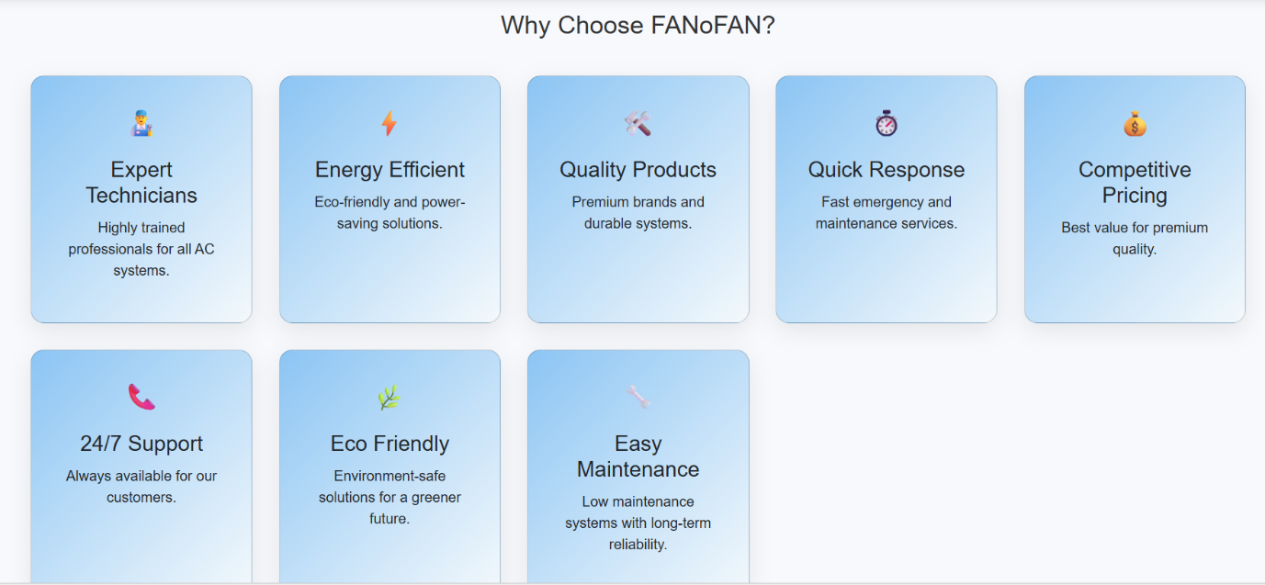
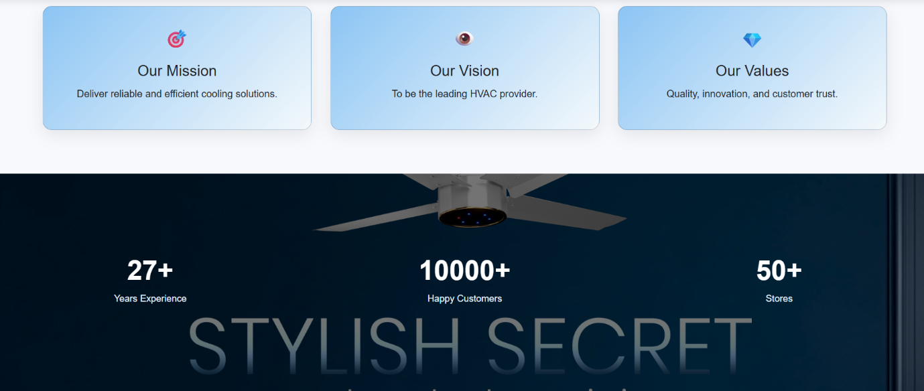
5.Feedback

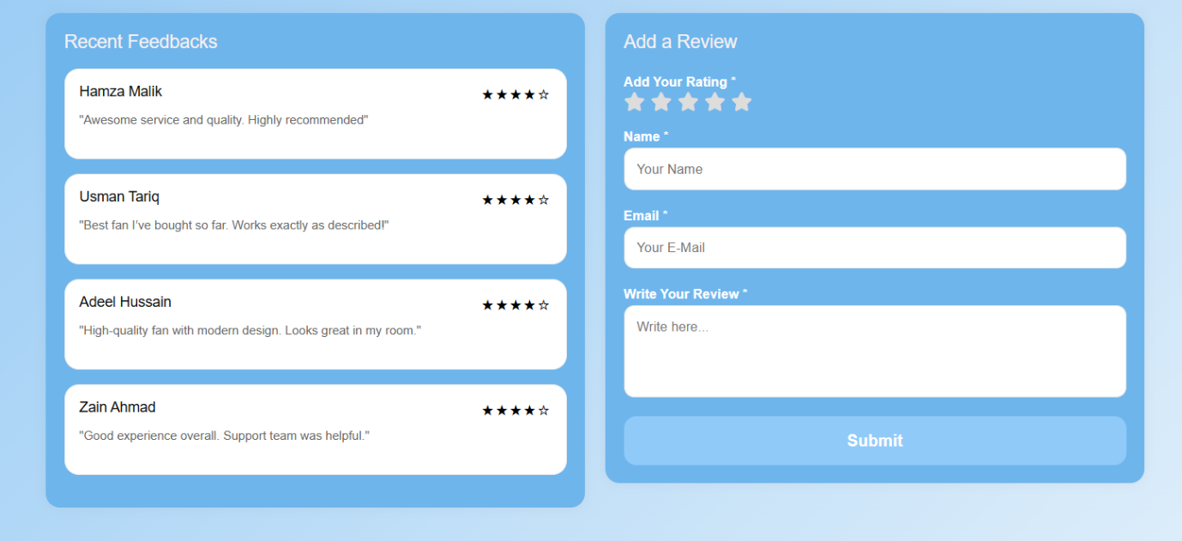

“Our Feedback section reflects our strong commitment to customer satisfaction and continuous improvement. We value every opinion shared by our users, as it helps us enhance the quality of our products and services. Customers can easily share their experience about ceiling fans, exhaust fans, stand fans, and table fans, allowing us to better understand their needs and expectations. This open communication ensures transparency, builds trust, and helps FANoFAN deliver a reliable and user-friendly shopping experience for everyone.”

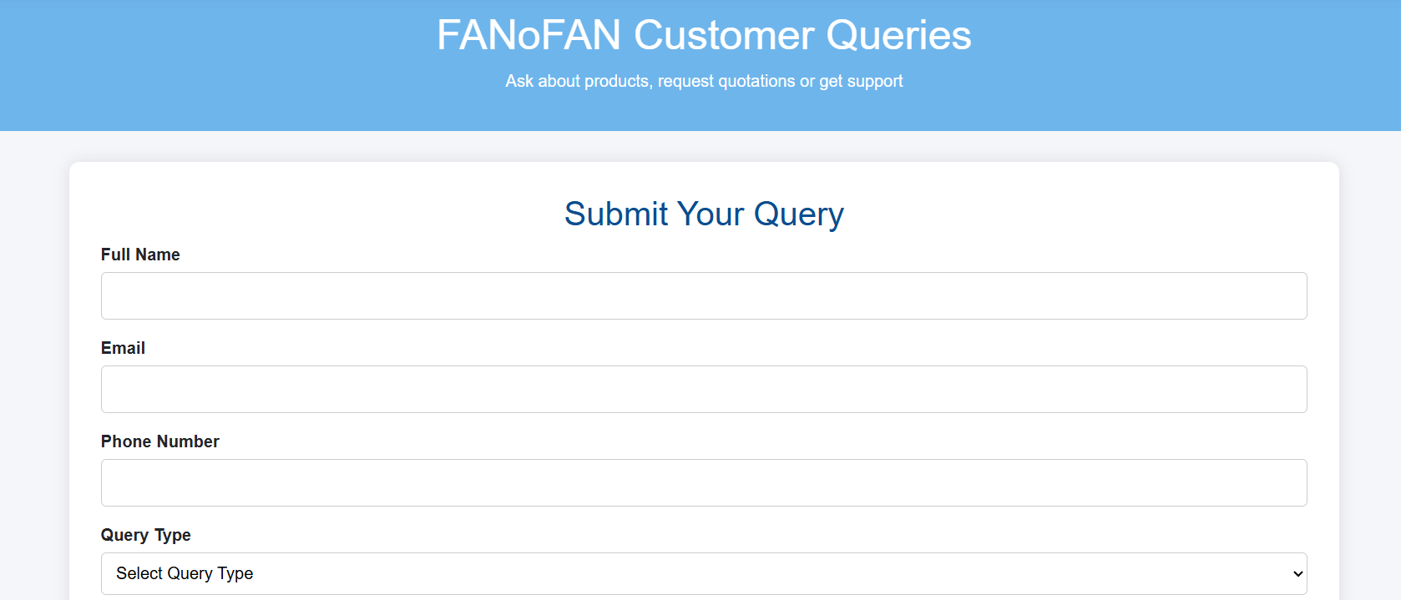
6.Queries

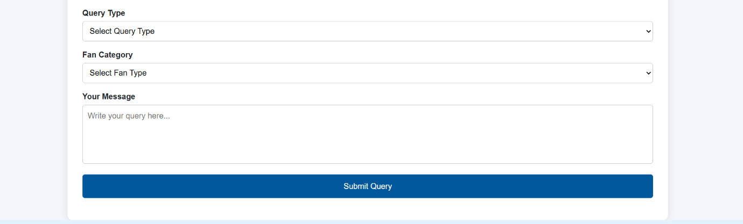
The Queries section is designed to assist customers with any questions related to our products, orders, or website services. Whether you need guidance in choosing the right ceiling fan, exhaust fan, stand fan, or table fan, or require support with purchasing and delivery, our team is always ready to help. We aim to provide clear, quick, and helpful responses to ensure a smooth and satisfying experience for every visitor. This section strengthens communication between FANoFAN and its customers, making support easily accessible whenever needed.

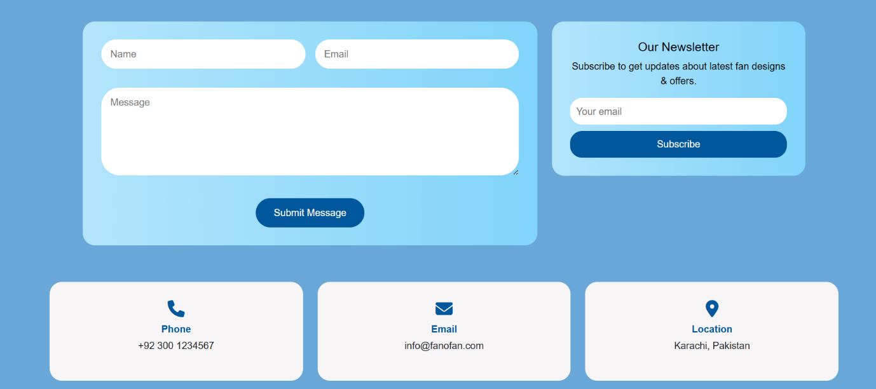

7.Contact
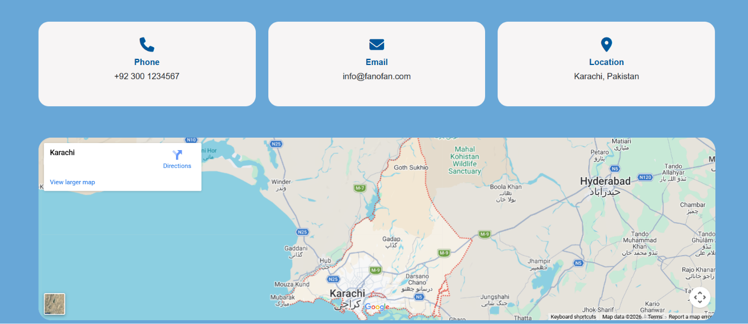
8.Site Map

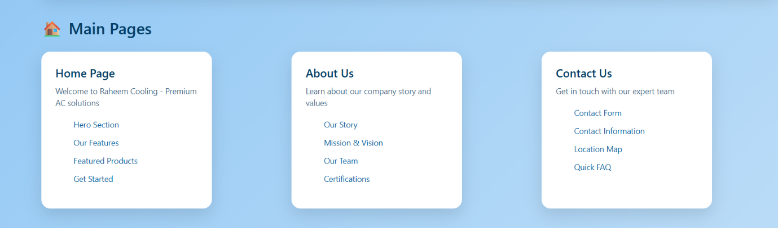

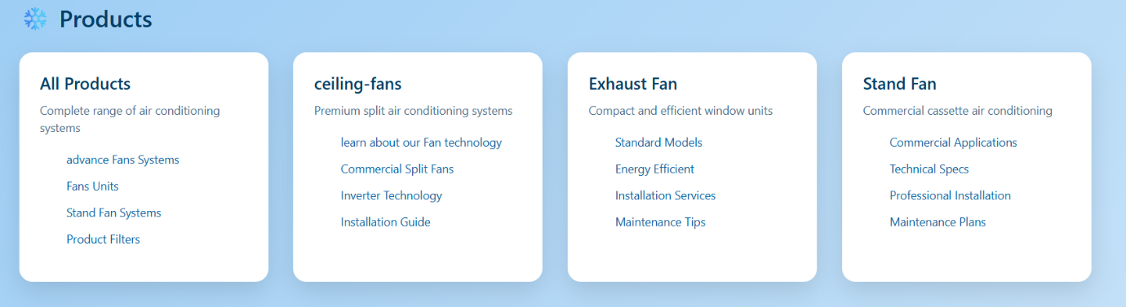

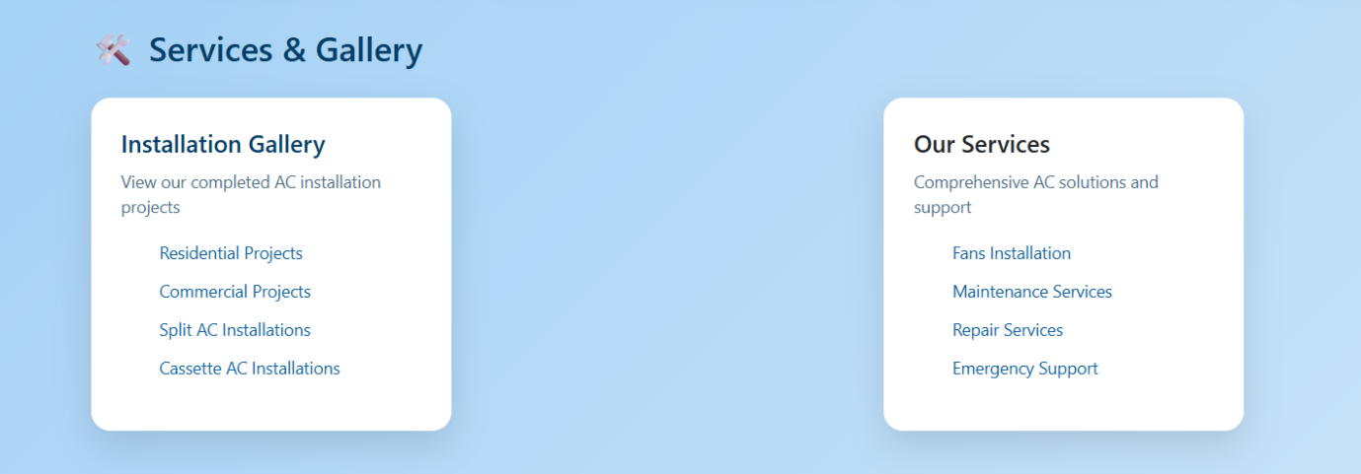

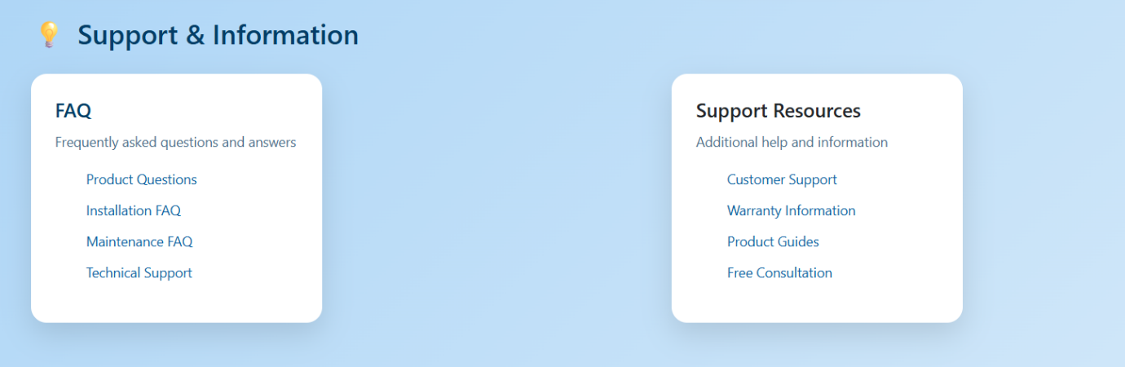
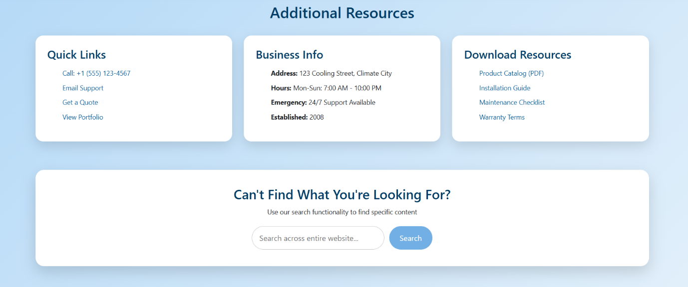

- Clear Website Structure: The site map provides an organized overview of all pages, helping users navigate the website easily.
- Main Pages Access: Includes quick links to Home, About, Products, Feedback, Queries, and Contact pages.
- Product Categories: Displays separate sections for Ceiling Fans, Exhaust Fans, Stand Fans, and Table Fans for simple browsing.
- User Convenience: Helps visitors find important information quickly without searching through multiple pages.
- Improved Navigation: Enhances overall user experience by showing the complete website layout in one place.
- Support & Information Links: Guides users to customer support, feedback forms, and query sections efficiently.

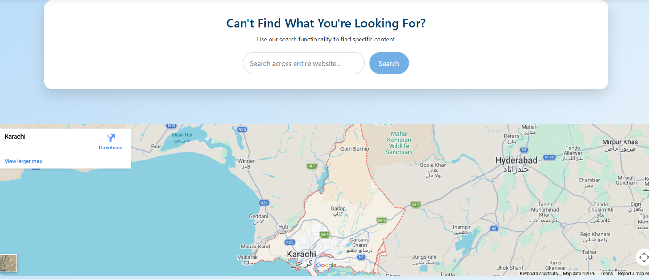

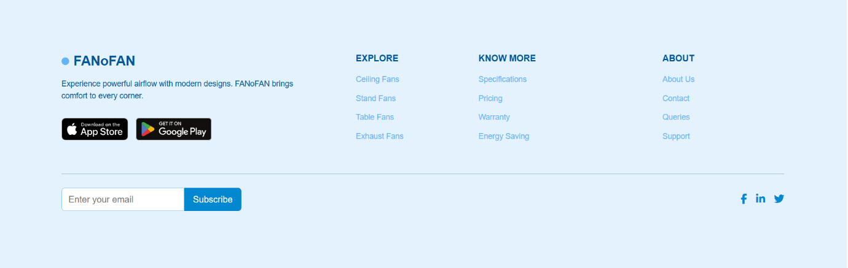
9. Footer

